

JAVA PROGRAMMING DSC261-3

Name: Nikhil George Noronha
Registration no :2541446
Date - 14/06/2026
Faculty – Dalwin Sir

INTRODUCTION:
The Student Marks Analyzer is a Java program designed to store and analyze the marks of five students using a one-dimensional array. It demonstrates the use of arrays, methods, loops, and conditional statements to perform operations such as finding the highest mark, calculating the average mark, and counting the number of students who passed. This program helps in understanding the basic concepts of array manipulation and data processing in Java.

Code:
import java.util.Scanner;

class StudentMarks {
private int[] marks = new int[5];
public void readMarks() {
Scanner scanner = new Scanner(System.in);
System.out.println("Enter the marks of 5 students:");
for (int i = 0; i < 5; i++) {
marks[i] = scanner.nextInt();
}
}

public void findHighestMark() {
int highest = marks[0];
for (int i = 1; i < marks.length; i++) {
if (marks[i] > highest) {
highest = marks[i];
}
}
System.out.println("Highest Mark = " + highest);
}

public void findAverageMark() {
int sum = 0;
for (int mark : marks) {
sum += mark;
}
double average = (double) sum / marks.length;
System.out.println("Average Mark = " + average);
}

public void countPassedStudents() {
int count = 0;
for (int mark : marks) {
if (mark >= 50) {
count++;
}
}
System.out.println("Number of Passed Students = " + count);
}
}

public class Main {
public static void main(String[] args) {
StudentMarks analyzer = new StudentMarks();
analyzer.readMarks();
analyzer.findHighestMark();
analyzer.findAverageMark();
analyzer.countPassedStudents();
}
}

OUTPUT:
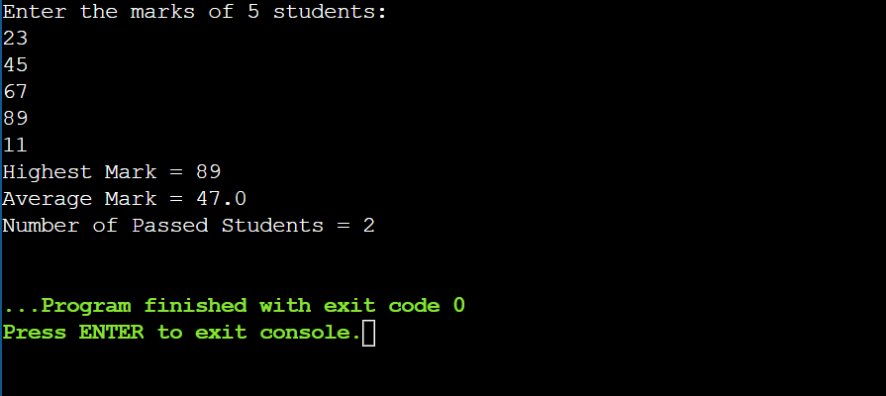

import java.util.Scanner;

class StudentMarks {
private int[][] marks;
public void createArray(int students, int subjects) {
marks = new int[students][subjects];
}

public void readMarks() {
Scanner scanner = new Scanner(System.in);
for (int i = 0; i < marks.length; i++) {
System.out.println("Enter marks for Student " + (i + 1) + ":");
for (int j = 0; j < marks[i].length; j++) {
marks[i][j] = scanner.nextInt();
}
}
}
public void displayMarks() {
System.out.println("\nStudent Marks");
for (int i = 0; i < marks.length; i++) {
System.out.print("Student " + (i + 1) + " : ");
for (int j = 0; j < marks[i].length; j++) {
System.out.print(marks[i][j] + " ");
}
System.out.println();
}
System.out.println();
}
public void findStudentTotal(int studentNo) {
int index = studentNo - 1; // Adjusting 1-based user input to 0-based index
int total = 0;
for (int j = 0; j < marks[index].length; j++) {
total += marks[index][j];
}
System.out.println("Total Marks of Student " + studentNo + " = " + total);
}
public void findStudentAverage(int studentNo) {
int index = studentNo - 1; // Adjusting 1-based user input to 0-based index
int total = 0;
for (int j = 0; j < marks[index].length; j++) {
total += marks[index][j];
}
double average = (double) total / marks[index].length;
System.out.println("Average Marks of Student " + studentNo + " = " + average);
}
public void findHighestMark() {
int highest = marks[0][0];
for (int i = 0; i < marks.length; i++) {
for (int j = 0; j < marks[i].length; j++) {
if (marks[i][j] > highest) {
highest = marks[i][j];
}
}
}
System.out.println("Highest Mark = " + highest);
}
}

public class Main {
public static void main(String[] args) {
Scanner scanner = new Scanner(System.in);

System.out.print("Enter the number of students: ");
int students = scanner.nextInt();
System.out.print("Enter the number of subjects: ");
int subjects = scanner.nextInt();
StudentMarks tracker = new StudentMarks();
tracker.createArray(students, subjects);
tracker.readMarks();
tracker.displayMarks();
System.out.print("Enter the student number: ");
int studentNo = scanner.nextInt();
tracker.findStudentTotal(studentNo);
tracker.findStudentAverage(studentNo);
tracker.findHighestMark();
}
}
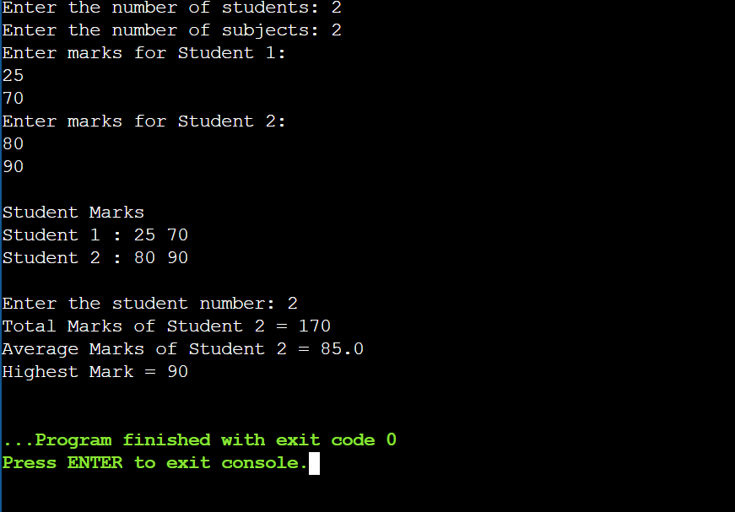

CONCLUSION:
This program successfully demonstrates the use of a two-dimensional array in Java to manage and analyze the marks of multiple students across multiple subjects. It dynamically creates the array based on user input, displays the marks in tabular form, calculates the total and average marks for a selected student, and identifies the highest mark scored overall. The program showcases the effective use of multidimensional arrays, methods, loops, and object-oriented programming concepts to organize and process academic data efficiently.

